**User manual**

1)Main Screen and Menu

The main screen of the application and is the entry point for all other screens contained in the application. The client will be able to browse through the menu from this point.

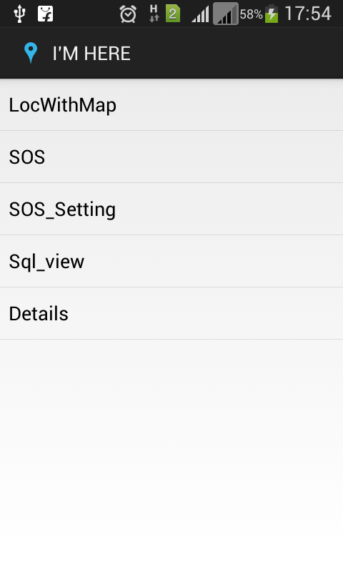

1.1) **Location with Map**

This feature allow the client to view their current location in coordinate form (Latitude and Longitude) as well as on the Google Map.

* Client will have to enable the GPS service on their GPS-Enabled Android Smartphone and within few seconds they will be able to see their exact coordinates in the display frame and on the Google Map with a pointer on their Location.

Menu->locWithMap

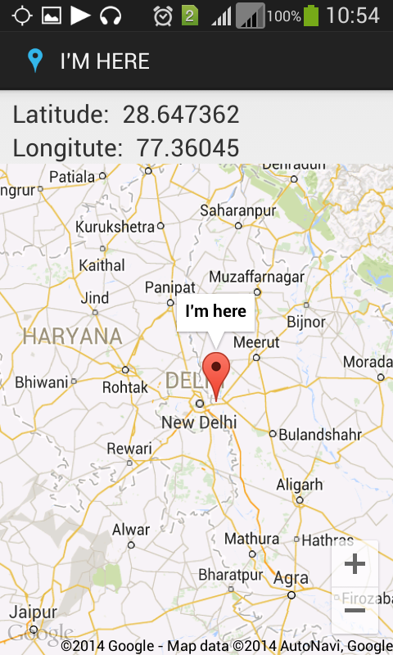

1.2) **SOS**

Menu->SOS

The SOS feature allow the client to send immediate emergency message and their exact position to their Dear one’s in just a click.

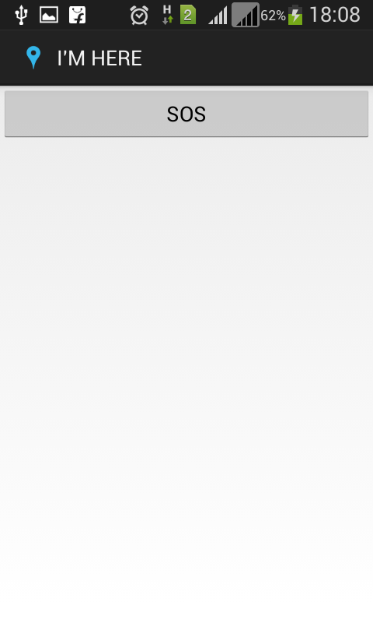

1.3) **SOS_Setting**

This feature allows client to modify, update, remove or just view the entries from the SOS database and client can modify their emergency contacts and messages.

1.3. a) Menu->SOS_Setting->

1) Enter emergency number

2) Enter emergency message

Update

3) Enter row ID to be deleted

Delete

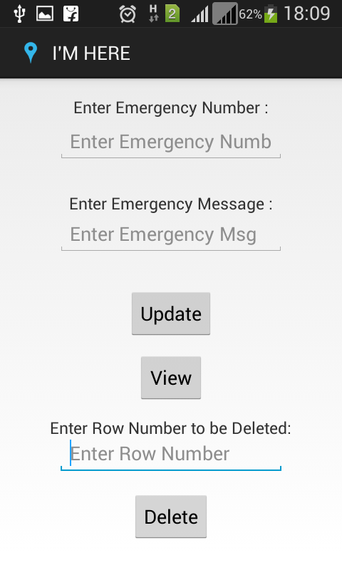

1.4)**sqlview**

Client can view the database where they have stored their emergency contacts and messages.

Menu->sqlview

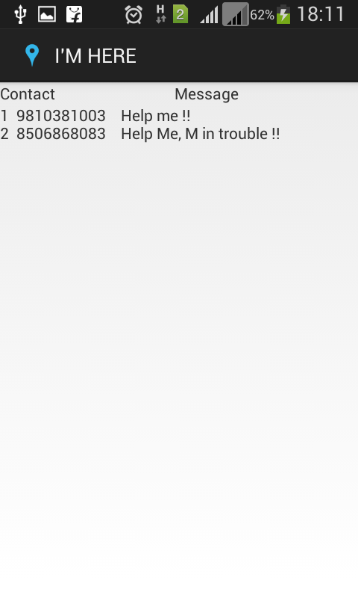

1.5**) chat**

Client can interact with other user through SMS.

Menu->chat->

1) Enter phone number

2) Enter SMS message

Send

